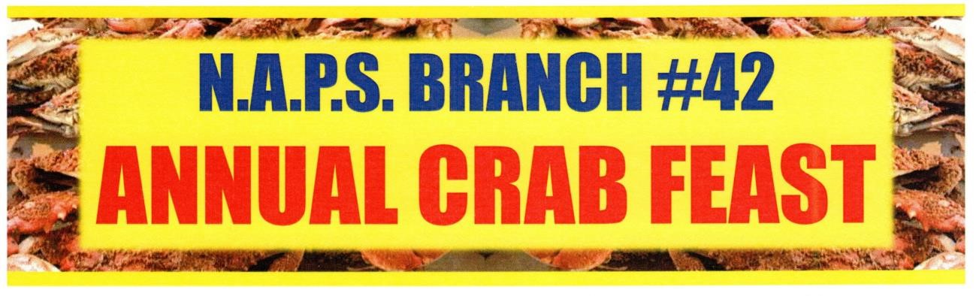

***Saturday, September 6, 2025***

***Boumi Shriners Center***

***5050 King Ave***

***Baltimore, MD 21237***

***2:00 P.M. – 6:00 P.M.***

***More info to come….***